**USE CASE STUDY REPORT**

Executive Summary:

Retail Markets are one of most profitable sector one can invest in current scenario. With rise in population retails markets are continuing their growth by expanding internationally . AllinAll in one such company which have presence in 50 locations across North America. To expand their business they wanted to analyze their current users to understand their shortcomings in retail sectors.

The company’s key growth strategies are to selectively expand its channels of distribution in important markets around the world without compromising the long-term value of the AllinAll; to increase sales in existing stores by developing new products; to increase its control over product supply; and to provide customer service that ensures a superior shopping experience.

The goal of the projects was to build a scalable database using different platforms like MySQL and NoSQL. Using these data, analysts can find different patterns which will help AllinAll to strategically plan before expanding their business to other locations. We used R to further analyze the data using R GGplot by connecting Mysql database to R .

# I. Introduction

This project aims to build a database management solution for a large-scale online retail shopping company named “All-in-All”which has 50+ stores across boston city and now they are offering online services after a long offline presence to attract more customers.

All-in-All sells almost sells 1 million products and does 10 thousand daily transactions approximately.

All-in-All provides customers with membership cards where a user gain reward points for each transaction. A user can use his reward points to pay a certain part of the bill. Apart from that membership customers can get free shipping on all the products. A non-membership customer can still purchase all these products he won’t be able to avail membership services.

This project is an attempt to build a large scale database system to support approximately 1 million products and 10 thousand daily transactions without compromising about “ACID (atomicity, consistency, isolation, durability) properties.

**OBJECTIVES**

* Maintain a record of products stock, price, brand, product batch for all the 50+ stores
* Maintain details of sales for each store across Boston
* Details of Store No, Address
* Details of Transactions (e.g. type of payment used)
* Details of Customer information (login details, address, first name, last name, membership, etc.)
* Details of shipping information (e.g. Shipping date, shipper name)

**Features:**

This database has two sides user interface and admin interface. In the user interface, customers can only see and order in the admin interface admin can update product information. An admin can be a customer at certain times when he purchases products

# 

# II. Conceptual Data Modeling

**ER Diagram for Online Retail Management.**

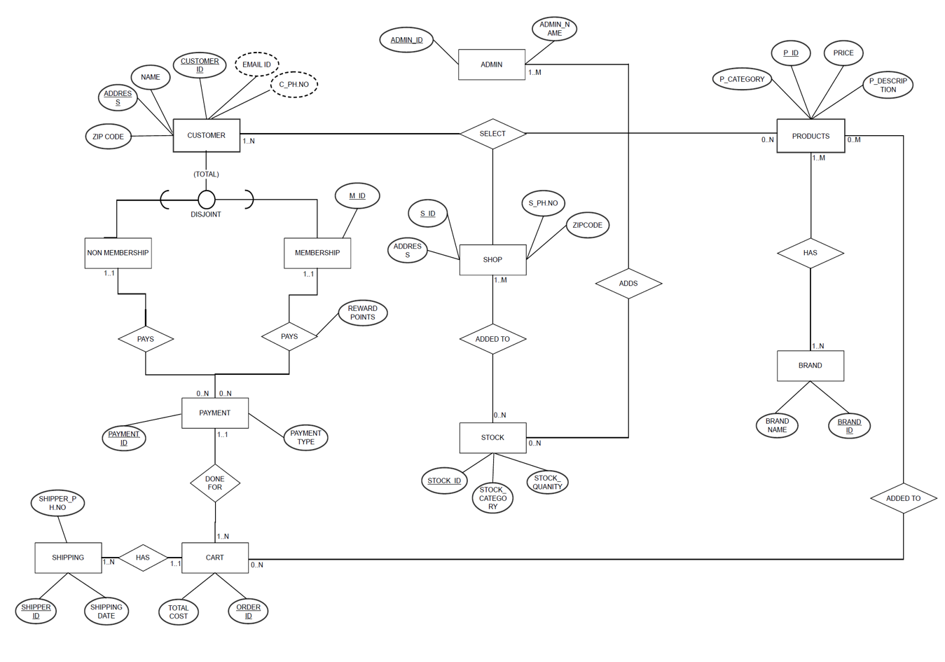

In this ER Diagram we have defined certain entities which are relevant while designing our database for online retail management.

We can see in this ER diagram,that customers can select product. A customer can select how many ever products he wants and same product can be purchased by multiple customer. Each customer can be uniquely identified by customer id which is a primary key and even products can be uniquely identified by product id. Customer has the liberty to even select the shop he wants to buy the product from

Each product has a brand.The products in the store and stocks are managed by the admin.

Finally the selected product by the customer is added in the cart, which had total cost and order id and we even provide different type of payment options.

Once the customer checks out they receive the shipping id and the package is delivered to the respective customer

UML Diagram

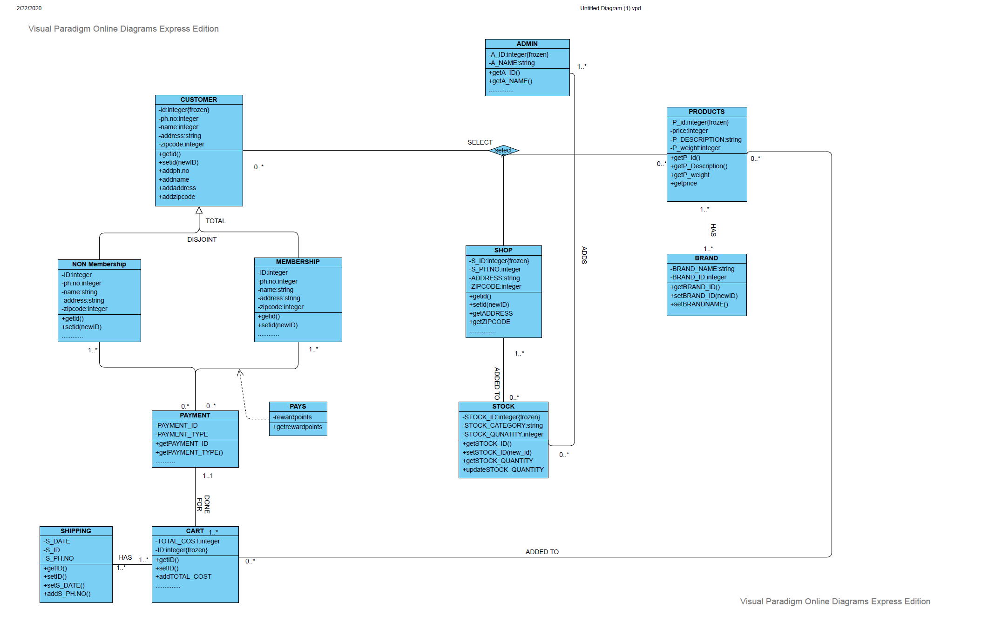

# Hggidgishdiuhfiushdfiuhdsiuhfvjdhfjdshfsdjhfjsdfh

Dsjhgdsgfisgdf

hsgdfshf

# III. Mapping Conceptual Model to Relational Model

**RELATIONAL MAPPING**

CUSTOMER (CUSTOMER_ID, NAME, ADDRESS, ZIPCODE, EMAIL_ID, PH.NO, M_ID)

CUSTOMER_EMAIL_ID (**CUSTOMER_ID**, EMAIL_ID, ADDRESS)

CUSTOMER_PH.NO (**CUSTOMER_ID**, C_PH.NO, ADDRESS)

NON-MEMBERSHIP(**NM_CUSTOMER_ID**)

MEMBER (**M_CUSTOMER_ID**, M_ID, REWARD_POINTS)

PAYMENT (PAYMENT_ID, PAYMENT TYPE, **M_ID**)

CART (PAYMENT_ID, ORDER_ID, TOTAL_COST)

SHIPPING (SHIPPER-ID, SHIPPING DATE, SHIPPER_PH.NO, ORDER_ID)

SELECT (**CUSTOMER_ID, P_ID, S_ID**)

SHOP (S_ID, ADDRESS, S_PH.NO, ZIPCODE)

STOCK_ADDED TO (**S_ID, STOCK_ID**)

STOCK (STOCK_ID, STOCK_CATEGORY, STOCK_QUANTITY)

ADDS (**STOCK_ID, ADMIN_ID**)

PRODUCTS (P_CATEGORY, P_ID, PRICE, P_DESCRIPTION)

PRODUCT_HAS (**P_P_ID, P_P_BRAND_ID**)

BRAND (BRAND_NAME, BRAND_ID)

**HIGHLETED – FOREGIN KEY, UNDSCORE-PRIMARY KEY, SOME ARE BOTH WHICH ARE REPRESENTED WITH UNDSCORE AND HIGHLIGHTER COMBINED**.

# IV. Implementation of Relation Model via MySQL and NoSQL

# Some of Relational Tables

**Question 1 which brand is most popular among grocery selected by customers?**

select b.b_name,count(b.b_name) as quantity from selects s inner join products p on p.p_id=s.p_id

inner join has h on h.p_id=p.p_id

inner join brand b on b.b_id=h.b_id

where p_category='Grocery'

group by s.p_id

order by quantity

desc;

select * from products;

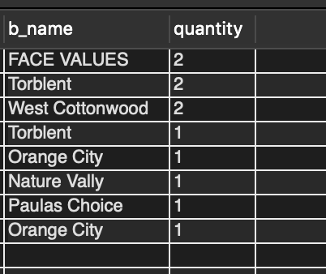

# Question 2 #list out which product category is purchased most

select p_category,count(p_category) as number_of_products

from customer c

inner join selects s on c.customer_id=s.customer_id

inner join products p on p.p_id=s.p_id

group by p_category

order by number_of_products

desc;

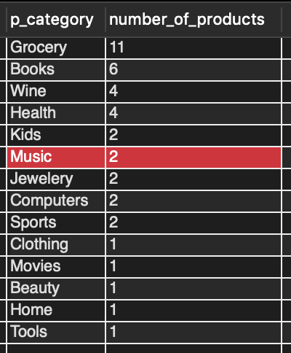

# Creation of table product in Mysql:

CREATE TABLE products(

p_category VARCHAR(20),

p_id VARCHAR(15) PRIMARY KEY NOT NULL,

price FLOAT NOT NULL,

p_description TEXT

);

**Populating product table example:**

insert into products (p_category, p_id, price, p_description ) values ('Grocery', '#356', '82.17', 'Appetizer - Mushroom Tart');

insert into products (p_category, p_id, price, p_description ) values ('Beauty', '#bf3', '82.24', 'Vitaminc -1500mg');

insert into products (p_category, p_id, price, p_description ) values ('Clothing', '#107', '43.22', 'Oneshot Automatic Soap System');

insert into products (p_category, p_id, price, p_description ) values ('Jewelery', '#f0b', '60.48', 'Seaweed Green ring-150kt');

**Creation of table customer in NoSQL:**

db.createCollection("customer");

**Populating customer table in NoSQL:**

db.customer.insert({

cid:"6234619",

cname:"jesse simpson",

address:"p o box 708 909 lacus street",

zipcode:"4618",

phno:"994844005”

});

**NOSQL**

**Question1**

db.data.aggregate([

{ $group:{_id:"$product", max: {$max:"$total" }}},

{$sort:{max:-1}}

]);

**Most costliest product**

{ "_id" : "Carrots - Mini, Stem On", "max" : 58.52 }

**Question 2**

db.customer.find({},{cname:1});

**Names of all customers**

{ "_id" : ObjectId("5e9e20804c2bc90d1c781e43"), "cname" : "amos keith" }

{ "_id" : ObjectId("5e9e20804c2bc90d1c781e44"), "cname" : "adam rocha" }

{ "_id" : ObjectId("5e9e20804c2bc90d1c781e45"), "cname" : "isahmel fields" }

{ "_id" : ObjectId("5e9e20804c2bc90d1c781e46"), "cname" : "amos keith" }

{ "_id" : ObjectId("5e9e20804c2bc90d1c781e47"), "cname" : "curran ayers" }

{ "_id" : ObjectId("5e9e20804c2bc90d1c781e48"), "cname" : "wylie merril" }

{ "_id" : ObjectId("5e9e20804c2bc90d1c781e49"), "cname" : "lewis valenzula" }

{ "_id" : ObjectId("5e9e20804c2bc90d1c781e4a"), "cname" : "isaac hawkins" }

{ "_id" : ObjectId("5e9e20804c2bc90d1c781e4b"), "cname" : "adrian valenzuela" }

{ "_id" : ObjectId("5e9e20804c2bc90d1c781e4c"), "cname" : "baxter vang" }

# Question 3: Average expenditure of females

{ "_id" : "Female", "avgerage" : 58.5

# V. Database Access via R or Python

# Question 1 -which brand is most popular among grocery selected by customers?

# rs <- dbSendQuery(mydb, "select b.b_name,count(b.b_name) as quantity from selects s inner join products p on p.p_id=s.p_id

# inner join has h on h.p_id=p.p_id

# inner join brand b on b.b_id=h.b_id

# where p_category='Grocery'

# group by s.p_id

# order by quantity

# desc")

db.fetch(rs)

**Result:**

|  |  |
| --- | --- |
|  |  |

# VII. Summary and recommendation

The goal of the study was to design and implement a database for a retail shopping company named Allinall. Allinall sells 100000 different products in 50 different places. They wanted to understand user data before expanding their business to other locations. We built a database to capture user data across 50 different stores which will help analysts to implement statistics using this data. For a proper format and to structure the data we need a well governed database.

Using relational database, it is possible to get relational tables where we can connect tables using joins. Using which is a short come of NoSQL database we get link one table to other to find relations across different attributes.

NoSQL database provides flexibility. NoSQL will be perfect choice for large companies like AllinAll to capture real time data which relational database lack in. NoSQL provides MapReduce function which can help to retrieve large data in short time . Although each database have their own lows and ups for a retail company that deals with 100000 customers everyday NoSQL database provides better flexibility.